Scott Fenton

Homework 2

CS320

**1. Let us define that a positive integer greater than 1 is called hilarious if the sum of its unique prime factors is a prime itself. Therefore, all primes are hilarious. Also, for example, 12 is hilarious, because its unique prime factors are 2 and 3, and their sum 5 is a prime, too. On the other hand, 84 is not hilarious, because 84 = 22** **3****7 and 2 + 3 + 7 = 12, which is not a prime.** a.)

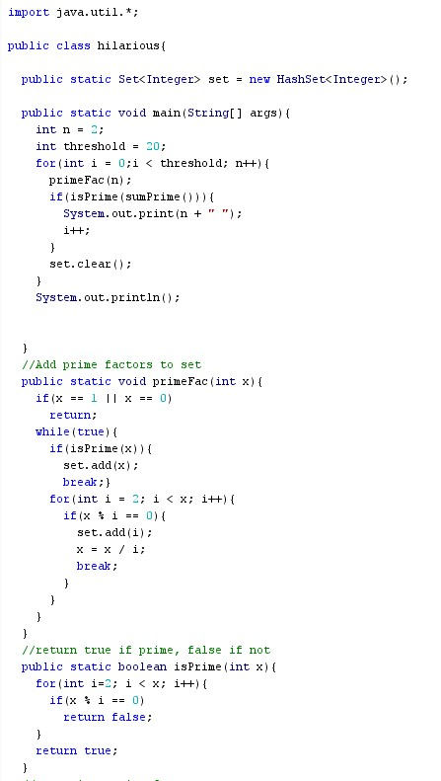

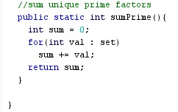

b. The first twenty hilarious numbers are 2,3, 4, 5, 6, 7, 8, 9, 10, 11, 12, 13, 16, 17, 18, 19, 20, 22, 23, 24.

**2. Write down the prime factorization (in ascending order) of each of the following integers (Example: 720 = 24****32****5).**

1. 258 = 2 * 3 * 43

1. 100000 = 25 * 55

1. 6250 = 2 * 55

1. 104 = 23 * 13

**3. Use the Euclidean algorithm to determine the following greatest common divisors. Write down every step in your calculation.**

**a.)** gcd(3300, 550) = 550

3300 = (550 * 6) + 0

**b.)** gcd(177,300) = 3

177 = (123 * 1) + 54

gcd(123,54)

123 = (54 * 2) + 15

gcd(54,15)

54 = (15 * 3) + 9

gcd(15,9)

15 = (9 * 1) + 6

gcd(9,6)

9 = (6 * 1) + 3

gcd(6,3)

6 = (3 * 2) + 0

gcd(177, 123) = 3

**c.)** gcd(912, 625) = 1

912 = (625 * 1) + 287

gcd(625, 287)

625 = (287 * 2) + 51

gcd(287, 51)

287 = (51 * 5) + 32

gcd(51,32)

51 = (32 * 1) + 19

gcd(32,19)

32 = (19 * 1) + 13

gcd(19,13)

19 = (13 * 1) + 6

gcd(13,6)

13 = (6 * 2) + 1

gcd(6, 1)

6 = (1 * 6) + 0

gcd(912,625) = 1

**4. Matrices**

a.)



 (Subtract matrix on left side)

 (Define matrix M)

 (Multiply two matrices together)

Equations:

2a + 4c = 10 2(6-3c) + 4c = 10 c = 1 (Solve trivial equations)

2b + 4d = 24 2(17 – 3d) + 4d = 24 d = 5

a + 3c = 6 a = 6 – 3c a = 3

b + 3d = 17 b = 17 – 3d b = 2

 (Verify solution)

b.) The two equation below are true because any Zero-one matrix reduces down too two different truth statements. Either 1 Λ 1 = 1 or 0 Λ 0 = 0 for equation 1. Or 1 V 1 = 1 or 0 V 0 = 0 for equation 2.

1. A Λ A = A
2. A V A = A

Given any Zero-one matrix A, a union or intersection of another matrix will always yield the original matrix A.

Ex:

 (The below equations hold true)

1 Λ 1 = 1

0 Λ 0 = 0

 (The below equations hold true)

1 V 1 = 1

0 V 0 = 0

**5. Use rules of inference to show whether the following arguments are valid or not:**

**a.)** If a course is boring and taught at a late time, the students will fall asleep. The course is boring, and the students do not fall asleep. Therefore, the course is not taught at a late time.

1. : Course is boring
2. : Course is taught at a late time
3. : Students will fall asleep

Step 1: (P ^ Q) Hypothesis

Step 2: P Simplification 1

Step 3: P 🡪 R hypothesis

Step 4: P ^ ~R hypothesis

Step :

Step 5: ~Q

**b.)** All UMB students are Red Sox fans. Whenever the Red Sox win, all Red Sox fans celebrate. The Red sox won. Therefore, Kermit, who is a UMB student, celebrates.

P : all umb students are red sox fans

Q : Red sox win

R : Red sox fan celebrate

Step 1: Q Hypothesis

Step 2: P Hypothesis

Step 3: P ^ Q Conjunction 1 & 2

Step 4: Q Simplification 3

Step 5: Q 🡪 R hypothesis

Step 6 : R Modus ponens step 4 & 5

**c.)** If time travel were possible, someone from the future would have visited us. If someone from the future had visited us, we would have heard about it. We have not heard about it. Therefore, time travel is impossible.

1. : time travel is possible
2. : future visitors
3. : heard about future visitors

Step 1: P 🡪 Q hypothesis

Step 2: Q 🡪 R hypothesis

Step 3: P 🡪 R Hypothetical Syllogism steps 1 & 2

Step 4: ¬R Hypothesis

Step 5: ¬P Modus Tollens step 3 & 4

**6. Prove or disprove the following statements:**

**a.)** 2n+ 1 is prime for all positive integers n.

This can be Disproven by counterexample:

if n = 6, then 26 + 1 = 65.

65 is not a prime number because it is divisible by 5 and 13.

**b.)** Prove that for any integer x, x2+ x + 1 is odd.

The definition of an odd number is n = 2k + 1

The definition of an even number is n = 2k

Suppose x is even:

x = 2k

f(x) = (2k)2 + 2k + 1 f(x) = 4k2 + 2k + 1

f(x) = 2(k2 + k) + 1

f(x) = 2(b) + 1, for b = k2 + k

Suppose x is odd:

x = 2k + 1

f(x) = (2k + 1)2 + (2k + 1) + 1

f(x) = (4k2 + 4k + 1) + (2k + 1) + 1

f(x) = (4k2 +6k + 2) + 1

f(x) = 2(2k2 +3k + 1) + 1

f(x) = 2(b) + 1, for b = 2k2 + 3k + 1

For the equation x2 + x + 1, the result is always odd because the equation reduces down to the definition of an odd number, 2b + 1. Therefore, for any integer x, x2 + x + 1 is odd.

**c.)** For every integer n, n(n + 1) is even.

This can be rewritten as n2 + n is even.

Suppose n is even:

Definition of an even number, n = 2k

n2 + n = 4k2 + 2k

= 2(2k2 + k)

= 2(b), for b = 2k2 + k

Suppose n is odd:

Definition of an odd number, n = 2k + 1

n2 + n = (2k+1)2 + (2k + 1)

= (4k2 + 4k + 1) + (2k + 1)

= (4k2 + 6k + 2)

= 2(k2 + 3k + 1)

= 2(b), for b = k2 + 3k + 1

For both situations, n is even or n is odd, the resulting equation is the definition of an even number, 2k. This holds true because an even number is a number that can be divided by 2. Therefore, any integer n for n(n+1) is even.

**d.)** The product of three odd integers is odd.

The definition of an odd number is n = 2k + 1.

We can then say g = 2k + 1, m = 2k + 1, and d = 2k +1

f(g,m,d) = (2k + 1) * (2k + 1) * (2k + 1)

= (4k2 + 2k + 2k + 1) * (2k + 1)

= (4k^2 + 4k + 1) * (2k + 1)

= (8k3 + 4k2 + 8k2 + 4k + 2k + 1)

= 8k3 + 12k2 + 6k + 1

= 2(4k3 + 6k2 + 3k) + 1

= 2(b) + 1, for b = 4k3 + 6k2 + 3k

By using the definition of an odd number, the equation reduces down to f(g,m,d) = 2b + 1. 2b is the definition of an even number, and any even number plus 1 is odd. Therefore, the product of three odd integers is odd since it conforms to the definition of an odd number, n = 2k + 1

**7. Formalization of Logical Expressions:**

1. Franz and Erika are the only professors who play soccer.

Professor(Franz) Λ Professor(Erika) Λ PlaysSoccer(Franz) Λ PlaysSoccer(Erika) Λ

 [Professor(x) Λ PlaysSoccer(x) → x = Franz V x = Erika]

1. All CS320 students know each other.

x,y [CS320Student(x) Λ CS320Student(y) → Knows(x,y)]

1. Petra and Bert never take classes that are interesting.

x[Class(x) Λ Interesting(x) → ¬Takes(Petra, x) Λ Takes(Bert, x)]

1. Any UMB student will fail if he/she does not complete Assignment #1.

x[UMBStudent(x) Λ ¬Completes(x, Assignment1) → Λ Fails(x)

1. Andreas beats up all professors that fail him and do not fail his sister Susanne.

x[Professor(x) Λ Fails(x, Andreas) Λ ¬Fails(x, Susanne) → BeatsUp(Andreas, x)

1. There is at most one computer scientist who can dance.

¬x,y[x ≠ y Λ CS(x) Λ CS(y) Λ CanDance(x) Λ CanDance(y)]

1. There is one UMB student who is taller than 7 feet and taller than all other UMB students.

x[(UMBStudent(x) Λ TallerThan(x, seven-feet) Λ y[x ≠ y Λ UMBStudent(y) → TallerThan(x,y)]]

h.) All UMB students who work full-time prefer evening classes.

x[UMBStudent(x) Λ WorksFullTime(x) → Prefers(x, EveningClasses)]

1. There are no scientists who are neither crazy nor dangerous.

x[Scientist(x) → Crazy(x) V Dangerous(x)]

1. George and Claudia always attend the same courses.

x[Course(x) → (Takes(George,x)) ←→ Takes(Claudia, x))]